Q.1) Magenta is a combination of -
a) Red and blue light
b) Red and green light
c) Blue and green light

Q.2) What are the Elements of the Exposure Triangle?
a) Aperture – White Balance – Shutter Speed
b) Shutter Speed – ISO – Camera Mode
c) Aperture – ISO – Shutter Speed
d) ISO – White Balance – Flash Power

Q.3) Who Photographed the Famous Picture ‘The Afghan Girl’?
a) Steve McCurry
b) Cindy Sherman
c) David LaChapelle
d) Mario Testino

Q.4) Which of these is NOT a Compositional Guideline in Photography?
a) Rule of thirds
b) Golden ratio
c) Leading lines
d) Three seconds rule

Q.5) ‘Camera’ is actually a Latin word meaning
a) Picture box
b) Room
c) Light box

Q.6) ‘Photography’ comes from the Greek words PHOTOS and GRAPHOS. What does it mean?
a) Light graphics
b) Light writing
c) Light drawing

Q.7) The amount of light or darkness on a photograph is known as the -
a) Exposure
b) Shutter Speed
c) Contrast
d) Sharpness

Q.8) Blue and yellow are _______ colors.
a) Primary
b) Related or analogous
c) Secondary
d) Complementary

Q.9) Elements- like lines, colors, or shapes, that are repeated over and over in a planned way creates a -
a) Focal point
b) Unity
c) Balance
d) Pattern

Q.10) M.F. Husain predominantly used which of these animals to depict a lively and free spirit in his paintings?
a) Tigers
b) Horses
c) Elephants
d) Cows

Q.11) Nand Lal Bose, Manjit Bawa, Tyeb Mehta are -
a) Classical Singers
b) English Poets
c) Photographers
d) Painters

Q.12) Raghu Rai is a well-known –
a) Painter
b) Film Director
c) Photographer
d) Sportsperson

Q.13) In which city is the Film and Television Institute of India located?
a) Pune
b) New Delhi
c) Mumbai
d) Ahmedabad

Q.14) Photography is basically –
a) Art
b) Science
c) Both art & science
d) Neither art nor science

Q.15) Which mode in the digital camera gives full control to the photographer?
a) Auto mode
b) Programmed mode
c) Manual mode
d) Flash mode

Q.16) Negative space in a photograph is –
a) The empty space
b) Where the subject is
c) Where the subject is pointing

Q.17) Dividing the frame into 9 equal segments with 2 vertical and 2 horizontal lines suggests which composition rule?
a) Golden ratio
b) Rule of thirds
c) Leading lines
d) Rule of odds

Q.18) This image incorporates which rule(s) of composition –
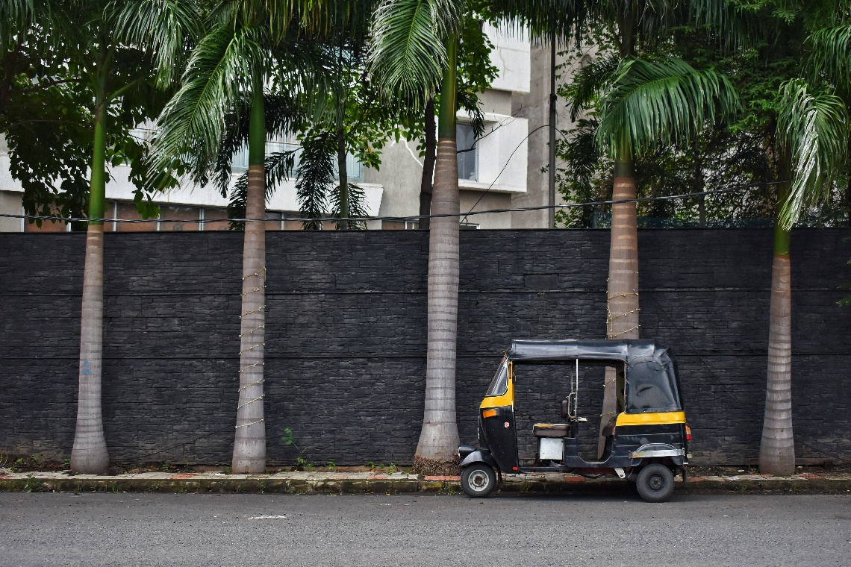
a) Rule of thirds
b) Rule of odds
c) Both of the above
d) None of the above

Next 5 questions are based on the below visual:
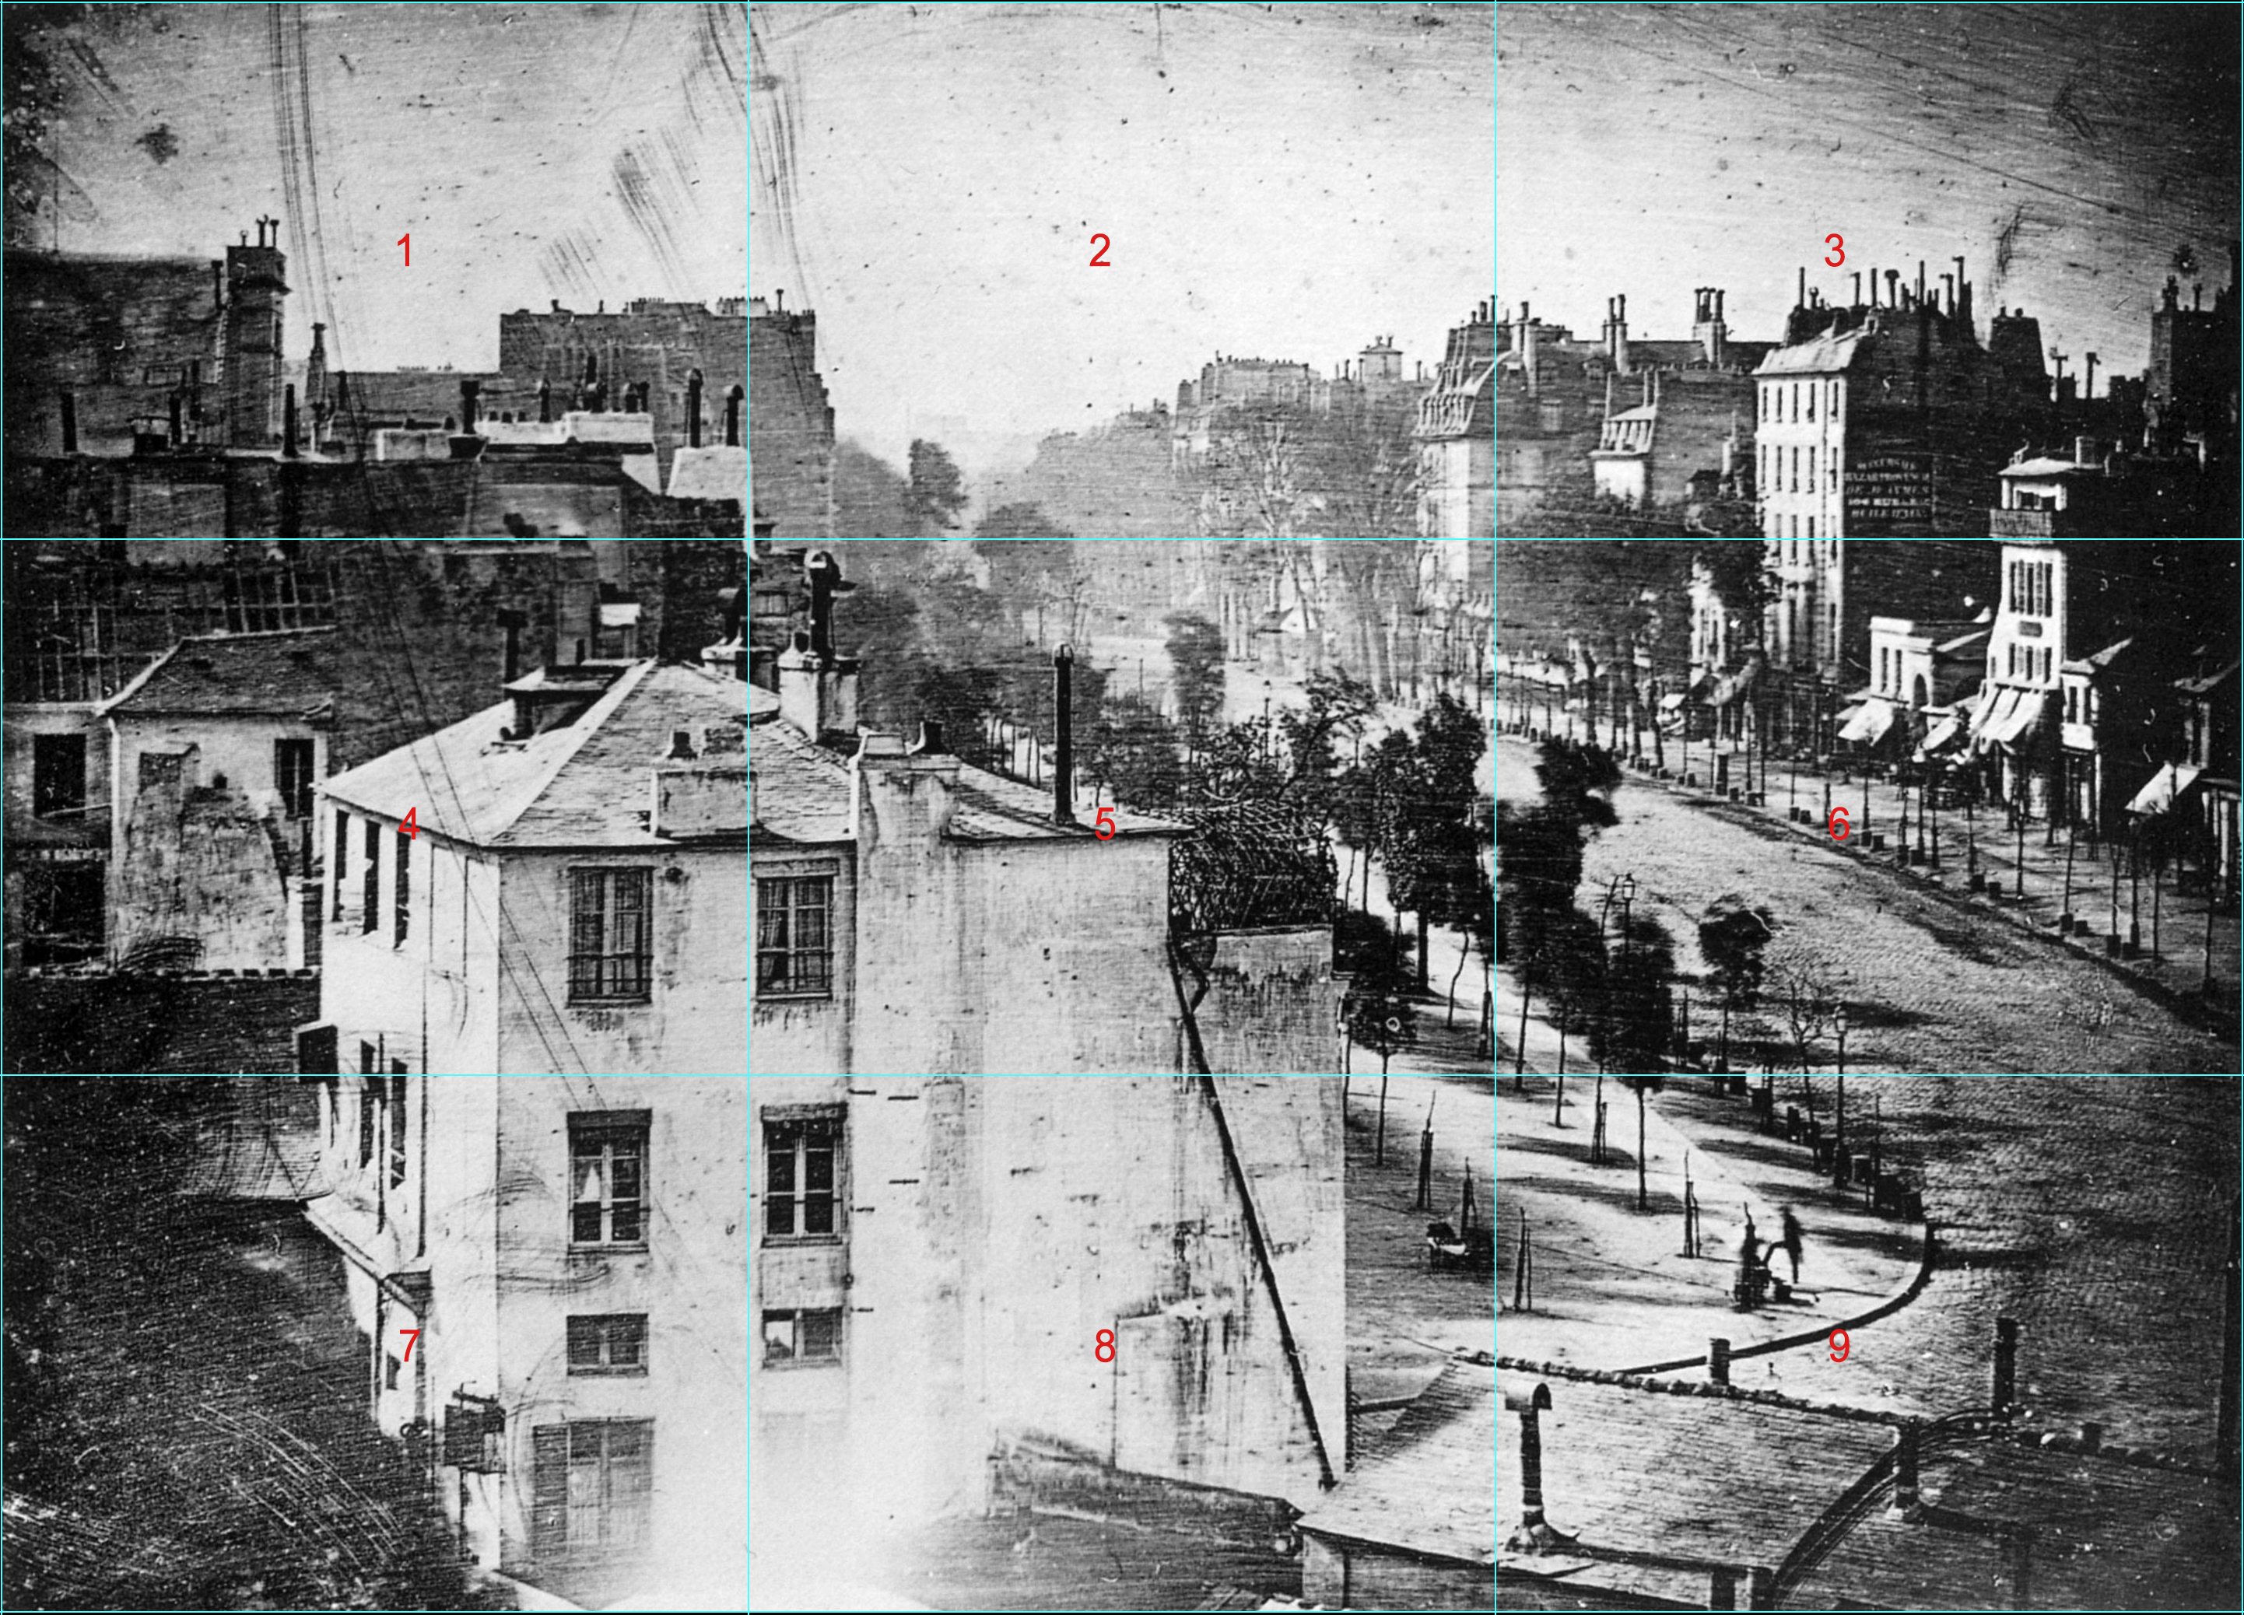
Q.19) What is this image?
a) A sketch
b) A drawing
c) A Photograph
d) A charcoal painting

Q.20) What is special about this photograph?
a) This is the 1st photograph ever taken.
b) This is the most accurate charcoal drawing ever.
c) This is the first photograph ever taken and preserved of humans.
d) This is a negative.

Q.21) In which zone is the human standing in this image?
a) Zone 1
b) Zone 9
c) Zone 6
d) Zone 4

Q.22) There is only one zone capturing a human in this image. What could be the reason for that?
a) It was a lock down and everyone else was in their homes.
b) All the other humans were moving and only this human was standing in one place for a long time.
c) It was a curfew and only one man violated the curfew.
d) None of the above.

Q.23) Who made this image?
a) Louis Daguerre
b) Joseph Nicéphore Niépce
c) Leonardo da Vinci
d) None

